**PACKAGES AND INTERFACE**

**Java Package**

* Group of similar types of classes.
* **2 types of packages:-**
  + Built-in package
  + User-defined package
* **Advantages:-**
  + Easy categorization as per use.
  + Makes it transferrable to other users.
  + Removes naming collision.

**Creating User-Defined Package**



* Defining a main method is **not** necessary.

**Compiling and Running Package**

* **To compile:** **javac -d . filename.java**
* **To run:** **java package_name.classname**

**Importing Package**



**Interface**

* **Skeleton** blueprint for class.
* We can define ***static*** variables only, and methods **without** body in interfaces.

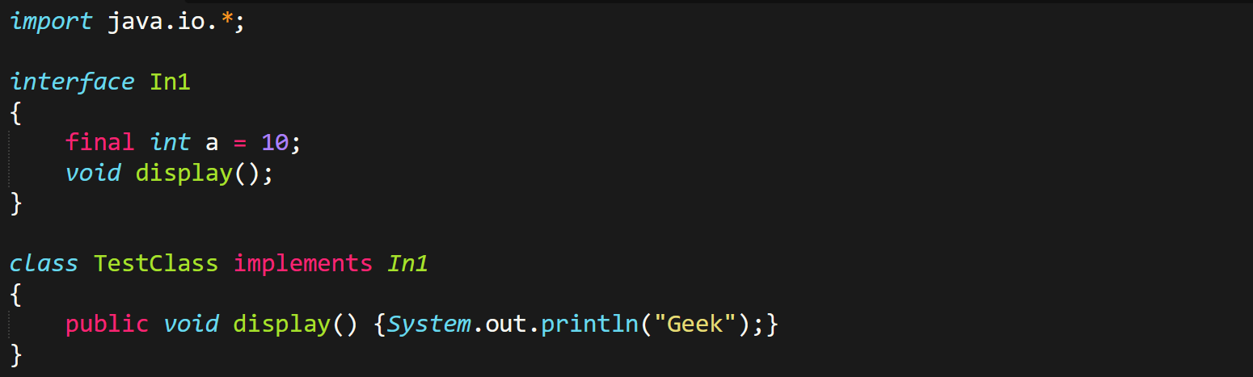

* Interface can use only ***public*** access specifier.